|  |  |  |
| --- | --- | --- |
| **Attribute** | **Parameter values** |  |
| Product Catalogue | D-Sub/DVI/HDMI connector |  |
| Connector Type | D-Sub |  |
| Male-Female | Female |  |
| Total Number of Pins | 9 |  |
| Row Number | 2 |  |
| Installation method | Bend insertion |  |
| Rated current | 1.5A |  |
| Operating temperature range | -40℃~+105℃ |  |

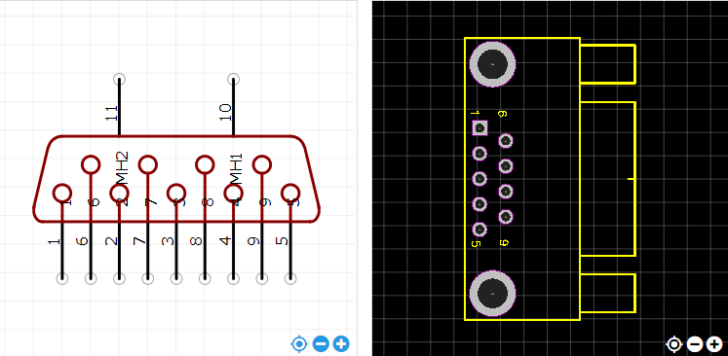

<https://item.szlcsc.com/76876.html>